

**FACULTY OF ENGINEERING**

**REPORT ABOUT WRITING A MATLAB CODE THAT CAN STORE EACH GROUP MEMBER’S AFFIRMATION ATTRIBUTES INTO A SINGLE VARIABLE AND A MATLAB CODE THAT CAN COPY VARIABLES OF EACH YEAR AND PUT THEM IN TABLES FOR EACH YEAR OF DATA, CONVERT TABLES INTO STRUCTURAL ARRAYS AND OUTPUTS EACH OF THE VARIABLES IN A SINGLE WORKBOOK**

**COURSE UNIT: COMPUTER POGRAMMING**

**LECTURER: MR. MASERUKA BENEDICTO**

**GROUP H**

**SUBMITTED BY;**

|  |  |  |
| --- | --- | --- |
| **STUDENT NAME** | **REG. NO.** | **COURSE** |
| LUGUNGA TIMOTHY | BU/UG/2024/2679 | AMI |
| BAHEMUKA GODWINS | BU/UG/2024/2583 | APE |
| KATUSIIME JOEL | BU/UP/2024/1031 | WAR |
| KABWERU ANDREW | BU/UG/2024/5057 | WAR |
| NABUKWASI SHAKIRA | BU/UP/2023/0862 | WAR |
| SIKUKU BELIZER RUTH | BU/UP/2024/0846 | AMI |
| NAZIWA PATRICIA | BU/UP/2024/0993 | PTI |
| CHEMONGES MIKIRAR | BU/UP/2024/1005 | WAR |
| NAGASHA RITTA | BU/UG/2024/5055 | AMI |
| SIDENYA KEVIN | BU/UP/2O24/3839 | WAR |
| ODONG ERICK PERRY | BU/UP/2024/1059 | WAR |
| WANYAM JOSEPH EROGO | BU/UP/2024/1077 | WAR |
| NANDIJJA LAILA | BU/UP/2024/3833 | WAR |
| NAMATA LILLIAN KIZZA | BU/UP/2024/0984 | MEB |
| DIKITAL JOHN | BU/UP/2024/1125 | WAR |
| SANYU JOY | BU/UP/2024/5348 | MEB |
| SEBATIKA COLLINE | BU/UP/2024/0845 | AMI |

***DATE OF SUBMISSION: ........./.............../........................***

***SUBMITTED TO: ........................................................................***

# ACKNOWLEDGEMENT:

We are grateful to the almighty God for this guidance and strength throughout this work our sincere thanks go to all who supported us and to every group member for their time and effort. Lastly, we acknowledge the sources and references that contributed to this report.

# ABSTRACT:

This report presents the development of MATLAB codes designed to manage group member data efficiently. The first code consolidates each group member’s affirmation attributes into a single variable, while the second code organises variables by array into separate tables. Additionally, a third code converts this table into structural arrays and outputs the variables into a single workbook. The implementation focuses on enhancing data handling for the MATLAB course, providing a practical solution for data organisation and retrieval.

# DEDICATION:

This report is dedicated to our lecturer, Mr. Masruka Benedicto who’s guidance and support have been instrumental in our learning journey. We also dedicate this work to group H members their unwavering encouragement throughout this project.



# DECLARATION:

We, group H members hereby declare that this report is our original work, carried out as part of the MATLAB course under the supervision of Mr. Maseruka Benedicto. All sources of information have been duly acknowledged ,and this work has not been submitted elsewhere for academic project.



KABWERU ANDREW ....................................................



LUGUNGA TIMOTHY.....................................................



ODONG ERICK PERRY...................................................



KATUSIME JOEL..............................................................



NABUKWASI SHAKIRA...................................................



NAGASHA RITTA..............................................................



NAZIWA PATRICIA............................................................

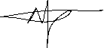

NANDIJJA LAILA.................................................................



SIKUKU BELIZER RUTH ........................................................



SIDENYA KEVIN ..............................................................

CHEMONGES MIKIRAR ...................................................



# APPROVAL:

We present this report, prepared entirely through our efforts. It includes the conversion of tables into structured arrays, the consolidation of all variables into a single workbook, and generation of MATLAB codes.

Table of Contents

ACKNOWLEDGEMENT: 2

ABSTRACT: 3

DEDICATION: 4

DECLARATION: 5

APPROVAL: 6

LIST OF ACRONYMS: 8

CHAPTER 1: INTRODUCTION: 9

1.1 Background: 9

1.2 Historical Development: 9

CHAPTER 2: STUDY COVERAGE: 10

2.1 NUMBER ONE: 10

CHAPTER 3: RECOMMENDATIONS AND CONCLUSION 15

3.1 Recommendation: 15

3.2 Conclusion: 16

CHAPTER 4: REFERENCES: 17

CHAPTER 5: APPENDICES 18

# LIST OF ACRONYMS:

**MATLAB**  MATrix LABoratory

**Struct**  Structure

# CHAPTER 1: INTRODUCTION:

# 1.1 Background:

MATLAB, which stands for matrix laboratory, is a high-performance programming language and environment designed primarily for technical computing. Its origins trace back to the late 1970s when Cleve Moler, a professor of computer science, developed it to provide his students with easy access to mathematical software libraries without requiring them to learn Fortran.

# 1.2 Historical Development:

* **Initial Development:** The first version of MATLAB was created in Fortran in the late 1970s as a simple interactive matrix calculator. This early iteration included basic matrix operations and was built on top of two significant mathematical libraries: LINPACK and EISPACK, which were developed for numerical linear algebra and eigenvalue problems, respectively.
* **Commercial Launch:** MATLAB was officially launched as a commercial product in 1984 by MathWorks, a company founded by Moler along with Jack Little and Steve Bangert. This marked the transition from a simple calculator to a comprehensive programming environment. The software was reimplemented in C, enhancing its capabilities with the addition of user-defined functions, toolboxes, and graphical interfaces.
* **Expansion and Toolboxes:** Over the years, MATLAB has expanded significantly. By the late 1980s, it had introduced several specialized toolboxes for various applications, including control systems and signal processing. The introduction of the Simulink environment further allowed users to model and simulate dynamic systems graphically.
* **Modern Enhancements:** Recent versions of MATLAB have introduced features like the Live Editor, which allows users to create interactive documents that combine code, output, and formatted text. This evolution reflects MATLAB's ongoing adaptation to meet the needs of its diverse user base across academia and industry.

# CHAPTER 2: STUDY COVERAGE:

# 2.1 NUMBER ONE:

1. **Code;**

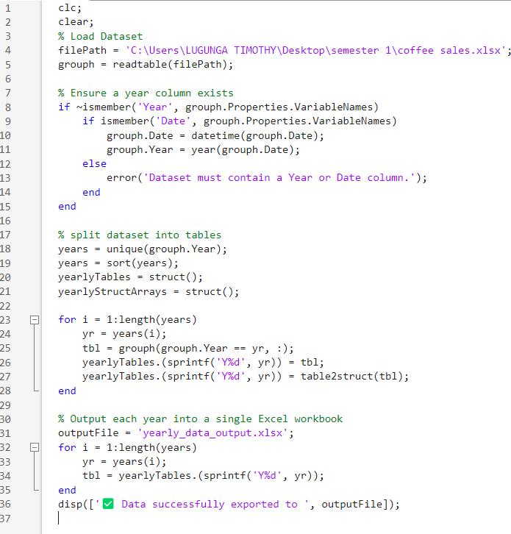

1. **Output;**

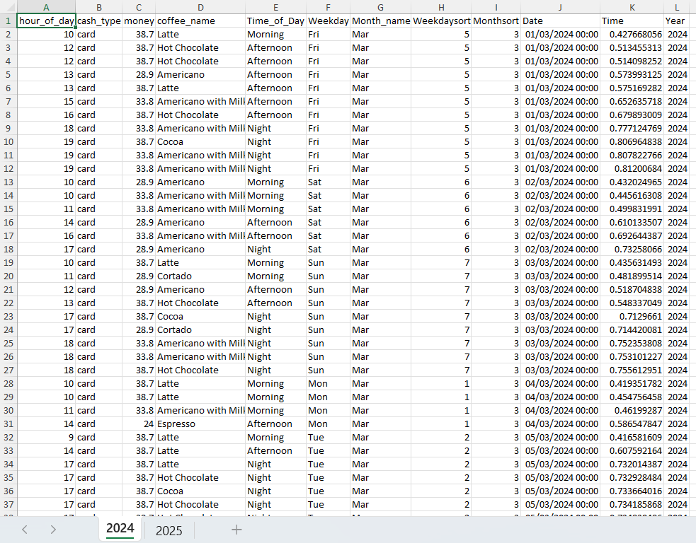

1. 2.2 NUMBER TWO:
2. **Code;**

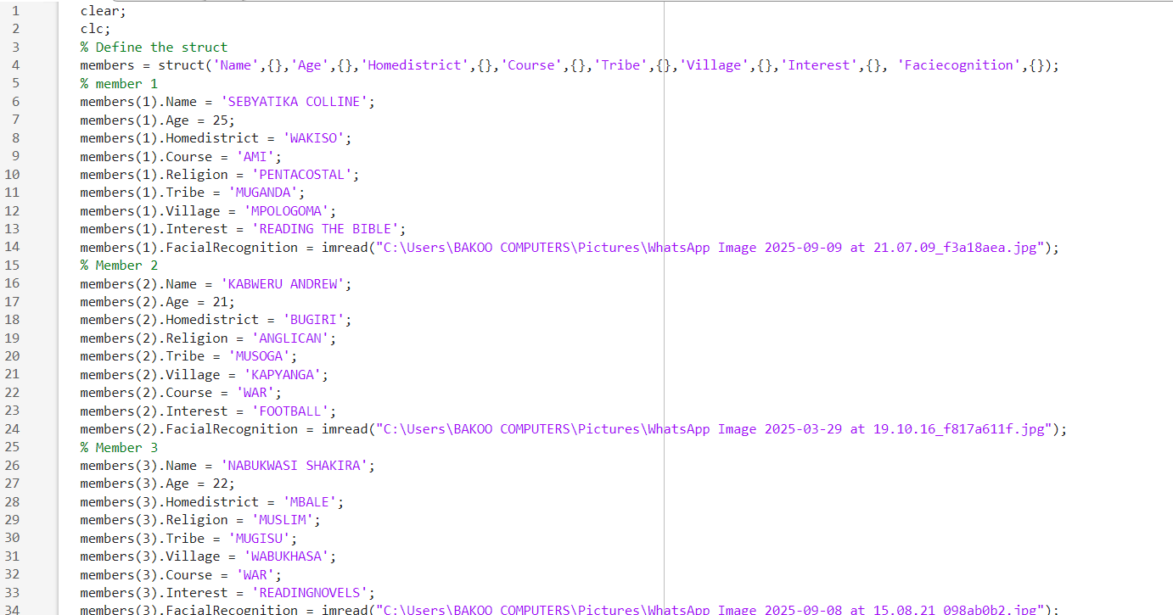

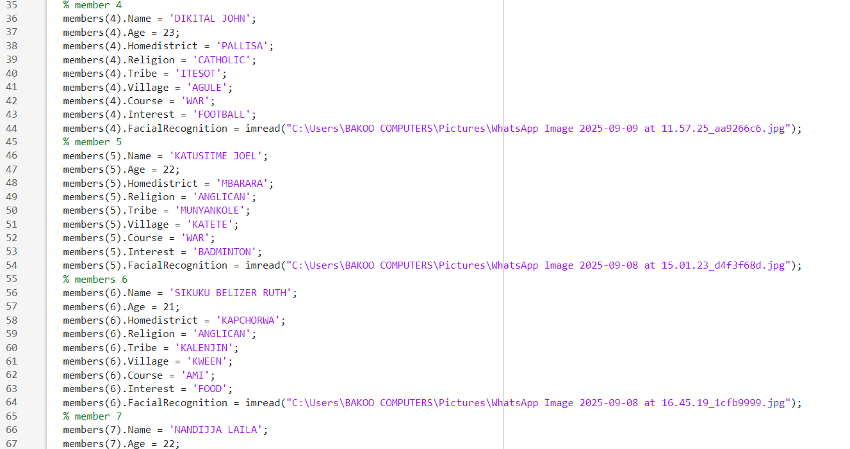

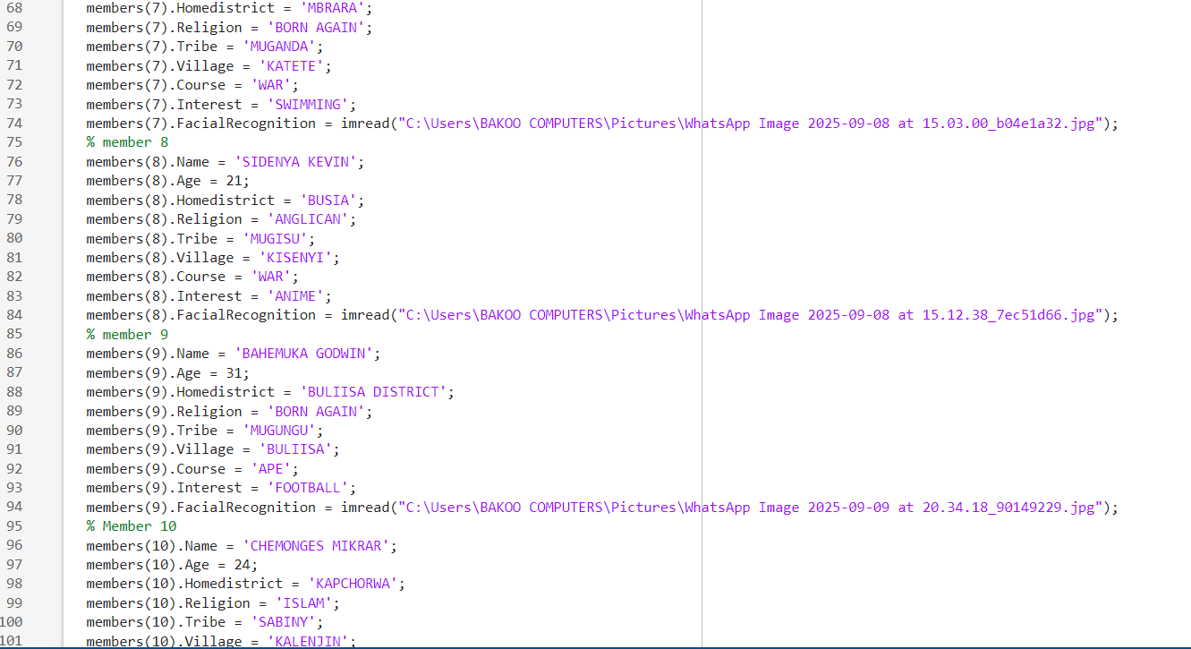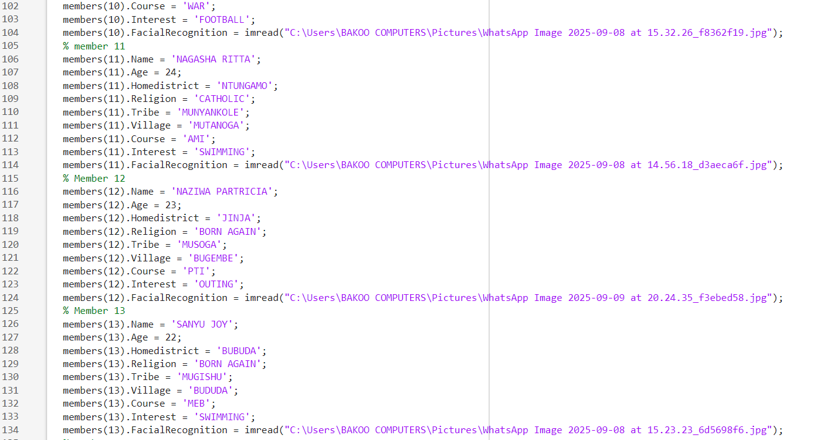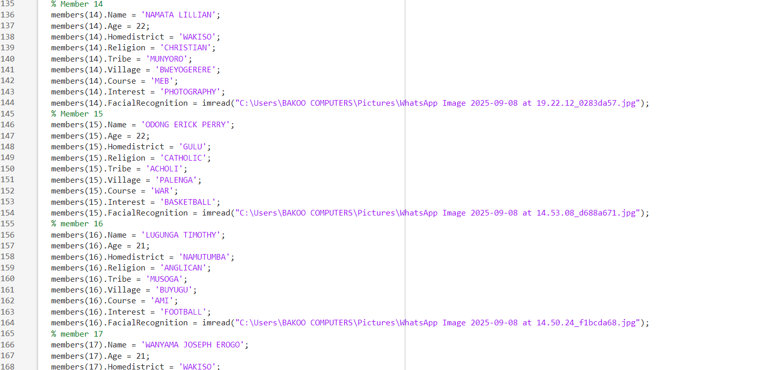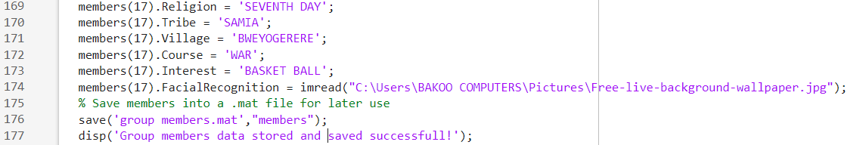

1. **Table: (output)**

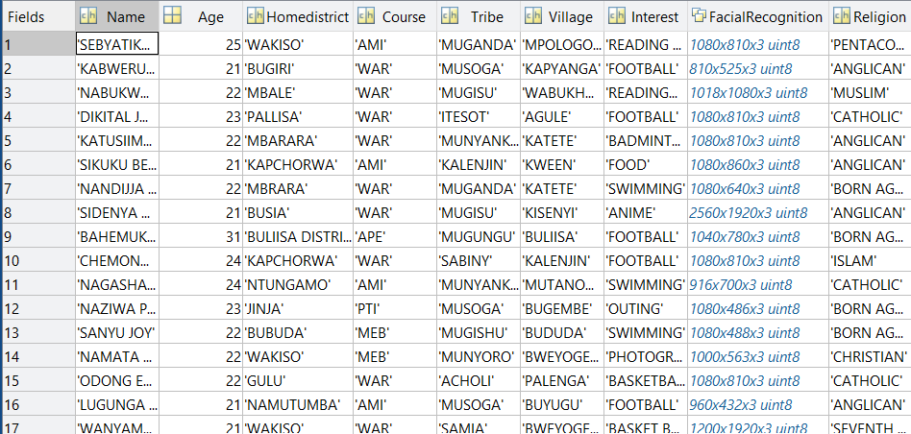

# CHAPTER 3: RECOMMENDATIONS AND CONCLUSION

# 3.1 Recommendation:

* Automate similar data processing tasks in the future project to save time and reduce the errors
* Regularly maintain and update MATLAB scripts to accommodate changes in data structure or new data sets
* Incorporate data validation steps to ensure accuracy during data consolidation and conversion
* Consider adding visualisation or reporting features to the MATLAB codes for easier interpretation of data.

# 3.2 Conclusion:

The report presents the successful development and implementation of MATLAB codes for effective data management. Each group member’s affirmation attributes were consolidated into single variables, yearly data was organised into tables and all tables were converted into structural arrays with outputs compiled into a single workbook. This systematic approach ensures organised accurate and easily retrievable data demonstrating the efficiency and reliability of the implemented methods

# CHAPTER 4: REFERENCES:

* Matlab for Beginners by Peter I Kattan
* An Introduction With Applications by Amos Gilat
* Matlab for Engineering Applications by William Palm
* Matlab for Brain and Cognitive Scientists by Mike X Cohen
* Essential Matlab for Engineers and Scientists by Brain Hahn and Daniel Valentine

# APPENDICES

